Congo, Dem. Rep.

## Freedom House political status

The data set shows the Freedom House political scores and status of the country each year.

## # A tibble: 19 x 5  
## country iso3c date mean status   
## <chr> <chr> <dbl> <dbl> <chr>   
## 1 Congo, Dem. Rep. ZAR 1996 6.5 Not Free  
## 2 Congo, Dem. Rep. ZAR 1998 6.5 Not Free  
## 3 Congo, Dem. Rep. ZAR 2000 6.5 Not Free  
## 4 Congo, Dem. Rep. ZAR 2002 6 Not Free  
## 5 Congo, Dem. Rep. ZAR 2003 6 Not Free  
## 6 Congo, Dem. Rep. ZAR 2004 6 Not Free  
## 7 Congo, Dem. Rep. ZAR 2005 6 Not Free  
## 8 Congo, Dem. Rep. ZAR 2006 5.5 Not Free  
## 9 Congo, Dem. Rep. ZAR 2007 5.5 Not Free  
## 10 Congo, Dem. Rep. ZAR 2008 6 Not Free  
## 11 Congo, Dem. Rep. ZAR 2009 6 Not Free  
## 12 Congo, Dem. Rep. ZAR 2010 6 Not Free  
## 13 Congo, Dem. Rep. ZAR 2011 6 Not Free  
## 14 Congo, Dem. Rep. ZAR 2012 6 Not Free  
## 15 Congo, Dem. Rep. ZAR 2013 6 Not Free  
## 16 Congo, Dem. Rep. ZAR 2014 6 Not Free  
## 17 Congo, Dem. Rep. ZAR 2015 6 Not Free  
## 18 Congo, Dem. Rep. ZAR 2016 6.5 Not Free  
## 19 Congo, Dem. Rep. ZAR 2017 6.5 Not Free

## Freedom House classification of political change

The data set shows the GDP growth and the ecomic growth classification of the country each year.

## # A tibble: 19 x 4  
## country iso3c date politicalChangeFH  
## <chr> <chr> <dbl> <chr>   
## 1 Congo, Dem. Rep. ZAR 1996 no change   
## 2 Congo, Dem. Rep. ZAR 1998 no change   
## 3 Congo, Dem. Rep. ZAR 2000 no change   
## 4 Congo, Dem. Rep. ZAR 2002 no change   
## 5 Congo, Dem. Rep. ZAR 2003 no change   
## 6 Congo, Dem. Rep. ZAR 2004 no change   
## 7 Congo, Dem. Rep. ZAR 2005 no change   
## 8 Congo, Dem. Rep. ZAR 2006 democratization   
## 9 Congo, Dem. Rep. ZAR 2007 no change   
## 10 Congo, Dem. Rep. ZAR 2008 autocratization   
## 11 Congo, Dem. Rep. ZAR 2009 no change   
## 12 Congo, Dem. Rep. ZAR 2010 no change   
## 13 Congo, Dem. Rep. ZAR 2011 no change   
## 14 Congo, Dem. Rep. ZAR 2012 no change   
## 15 Congo, Dem. Rep. ZAR 2013 no change   
## 16 Congo, Dem. Rep. ZAR 2014 no change   
## 17 Congo, Dem. Rep. ZAR 2015 no change   
## 18 Congo, Dem. Rep. ZAR 2016 autocratization   
## 19 Congo, Dem. Rep. ZAR 2017 no change

## Freedom House score trend

The plot shows the Freedom House scores trend of the country.

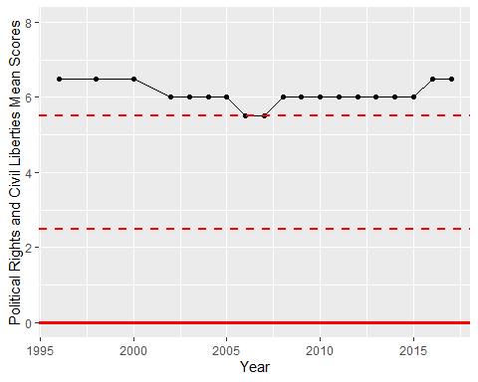

Freedom House Score Trend